Technology Meets the Rural Mobility as a Service (RMaaS) User:
A Co-Design Approach

Jenny Milne*
School of Engineering
University of Aberdeen, AB24 3FX Aberdeen, Scotland
Email: jenny.milne@abdn.ac.uk

Jana Sochor
Department of Space, Earth and Environment, Physical Resource Theory Division
Chalmers University of Technology, 41296 Gothenburg, Sweden
Email: jana.sochor@chalmers.se

Mark Beecroft
School of Engineering
University of Aberdeen, AB24 3FX Aberdeen, Scotland
Email: m.beecroft@abdn.ac.uk

Caitlin Cottrill^
School of Engineering
University of Aberdeen, AB24 3FX Aberdeen, Scotland

* corresponding author
^ deceased

Word Count: 7499 words + 0 tables (250 words per table) = 7499 words

Submitted August 1, 2023

0. ABSTRACT
The user experience is a critical part of any product development process and one which has often been overlooked in the field of Mobility as a Service (MaaS). Based upon the principles of Design Thinking and Co-Design, the research presented is grounded upon a hybrid workshop in Scotland in 2022. This workshop involved six MaaS-related technology solutions currently operating in urban, rural, and/or regional settings. Solutions were demonstrated to, then tested and evaluated by a mix of potential users, including local businesses, transport/service providers, young and elderly people. In addition, novel exercises and tools developed for the hybrid workshop, featuring a range of activities for participants (‘A Day in the Life’, story cubes and persona development) and a two-step evaluation framework for MaaS technology solutions (‘Designing Transport for All’). The workshop development, results, and outputs address four larger research objectives: (1) identifying potential MaaS use cases across a variety of user groups, including residents and visitors; (2) establishing user requirements for RMaaS; (3) determining practical barriers and opportunities for RMaaS; and (4) evaluating existing MaaS technology solutions and software, particularly in the context of transport poverty and lacking transport infrastructure. Key outputs include co-created personas, the stakeholder map, the RMaaS Customer Journey Map (illustrating touch- and pain points), the RMaaS User Mode Priority Hierarchy (demonstrating the misalignment between existing and desired mode offerings), the Impact and Value Frameworks, and the tools and templates developed for the workshop, available to researchers and practitioners.

Keywords: Mobility as a Service, Rural, Design, Personas, Customer Journey, Workshop, Evaluation
1. INTRODUCTION
In the last five years there has been an increase globally not only in MaaS (Mobility as a Service) ‘pilots’ but also in the number of commercial providers of MaaS solutions. There are a small handful of known providers but as the MaaS market has grown, so has the number of potential users.
MaaS, as a multi-modal, customer-facing, technology-based application, is being offered around the world. As part of the product development cycle, customer and/or user engagement and evaluation are critical for success. Yet, aside from research undertaken in e.g., Sweden (1-2), Finland (3-4), the Netherlands (5) and Hungary and the UK (6), the sharing of practical MaaS end-user customer journey experiences are limited, even more so in a rural setting. Furthermore, much MaaS research has taken an urban focus and/or has included more general surveys engaging with MaaS-related stakeholders or experts. But “compared with metropolitan areas, MaaS in small urban and rural areas might have different issues to deal with such as service span (higher demand of intercounty traveling, public transit service availability), limited or no fixed route transit service, and user acceptance (a more aging population and privacy concerns)” (7:2); issues that will be explored in this paper.
An important approach for studying these issues is grounded in the user perspective, namely that of Design Thinking and Co-Design (8). Such ‘tools’ are user-centric and involve the customer/user as part of the product design and implementation processes. This paper presents findings from a workshop cemented firmly upon a co-design methodology. The workshop’s innovative and unique design was central to being able to uncover and delve into key research areas within Rural MaaS (RMaaS) and mobility. The workshop and its outputs contribute to a larger research project on RMaaS which has four key objectives: 1) to identify use cases, 2) to establish user requirements, 3) to determine practical barriers and opportunities, and 4) to evaluate solutions and software in the field, particularly in light of transport poverty and lack of transport infrastructure. Within that context, this paper's purpose is to present the workshop results with particular focus on evaluation; the testing of designed templates; and identifying user requirements, as well as gaps, barriers, and opportunities. Other key outputs include co-designed personas, impact and value frameworks, a customer journey map, and a proposal to extend the ’diffusion of innovation’ model. This work also contributes with an array of practical tools and templates available to (R)MaaS practitioners.
Section 2 of this paper will provide a brief ‘state of knowledge’ review on the application of user-centred methods within MaaS research. Method (Section 3) outlines: the techniques used to deliver a hybrid workshop including six MaaS providers; the process of designing hybrid activities to generate co-designed personas, etc.; and the design of templates for evaluating the MaaS technology solutions. Section 4 presents the workshop results and analysis, whilst Section 5 provides concluding remarks, contributions, and recommendations.

2. INVOLVING THE USER IN THE DESIGN PROCESS
This section focuses upon Design Thinking, Co-Design and Personas in the context of rural mobility and MaaS. As will be demonstrated, there exists a gap in the application and academic documentation of design processes in the field of MaaS, and more specifically in RMaaS. Given the complex nature of MaaS, particularly in rural areas, and the need for problem defined solutions (9), this discovery is significant.

2.1 Design Thinking
Design Thinking (DT) places the user at the heart of the process of system change. DT is particularly relevant when there is a defined problem with the user experience as it is a collaborative and participatory tool to find solution/s to the problem/s. DT (and co-design; see below), at least in the UK, has been centred on the British Design Council’s (BDC) 2014 Double Diamond model describing design and innovation processes (10). It consists of four phases: Discover user needs; Define how user needs and the problem align; Develop, test, and refine potential solutions; and Deliver a solution. In 2019, the BDC recognised that design processes could be non-linear and updated the model, followed by further revisions in 2021 to encompass social and environmental factors, principally in relation to net zero (Figure 1).
A Science Direct ‘Advanced Search’ (in March 2023) of peer-reviewed journal articles and book chapters using the search field ‘Title, abstract or author-specified keywords’ found 75 results for ‘design-thinking’ ‘transport’ but zero results when also including the term ‘rural’. When searching this database and including the term ‘mobility as a service’ (instead of ‘transport’), articles are scarce. In contrast, Google Scholar lists additional relevant publications such as (8, 11). The grey literature contains even more relevant findings, especially research undertaken in Australia where the user is ‘put front and centre’ – e.g. by applying the BDC’s Double Diamond design process (10) – when developing a strategy for delivering MaaS in Queensland (12). That research identifies four crucial attributes when designing MaaS offers: Trust and Value, Sharing and Commitments, Competency, and Access (12). Other research explores to what degree service design was considered in four pilots in Gothenburg whilst also discussing the role of service design within MaaS innovation projects. The results were critical; instead of focusing on users and service design, MaaS development processes typically make assumptions about what will attract users and overly focus on technical integration and app development (13).
In summary, the term ‘design thinking’ is seldom found in transport-related, peer-reviewed journal article titles, abstracts, or key words. Furthermore, the evidence for this methodology being practically applied within MaaS developments is minimal.

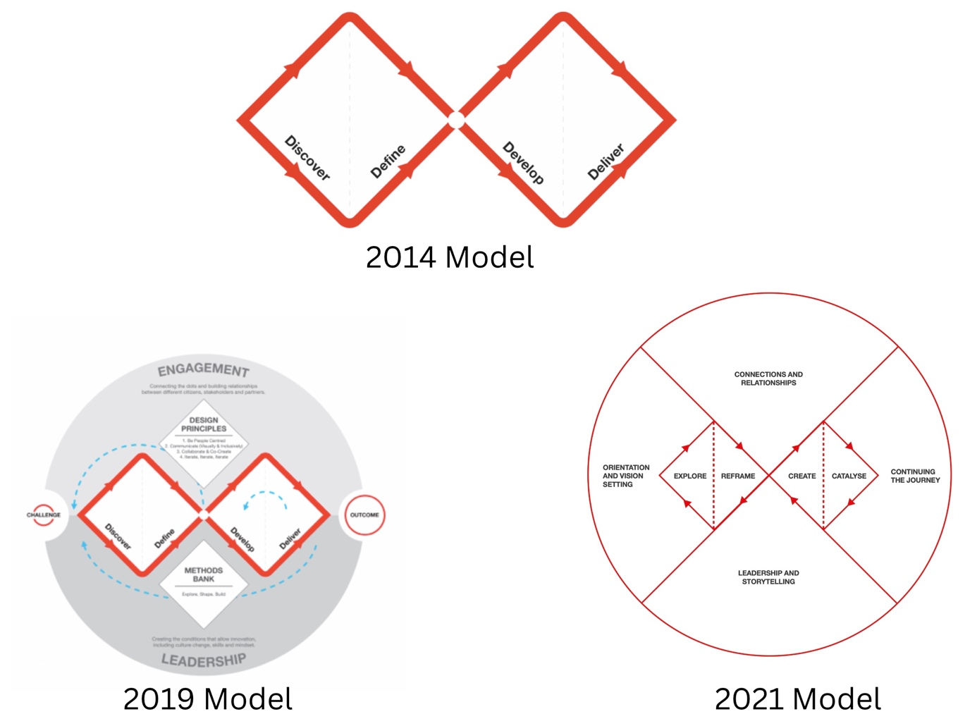

Figure 1 Design Thinking models from the British Design Council (10)
2.2 Co-Design, also known as Participatory Design
As acknowledged by the International Transport Forum (ITF), “user-focused models could serve as a starting point for better understanding what constitutes viable mass-scale MaaS models how they create value for users” (14:9). Co-Design (or Participatory Design) is one such model and entails “a distinct set of principles and practices for understanding problems and generating solutions. It signifies the active involvement of a diverse range of participants in exploring, developing, and testing responses to shared challenges” (15). Co-design has been recommended for developing inclusive mobility solutions – “Address user requirements through better engagement: co-participation and co-design workshops, focus groups and interviews, trainings, strong promotional activities. Equally, re-design of [sic] new and existing business models with the vulnerable users’ needs in mind” (16:53). Co-design (as a method) is more widely applied in the transport sector than is DT – e.g. autonomous vehicles, sustainable travel, and even mathematically (17) – but similarly to DT, it is seldom utilised in peer-reviewed journal articles at the level of title, abstract, or keywords.
Within MaaS developments, the Navigogo MaaS project, based in Scotland during 2016, is thus far unique in embracing fully the co-design methodology from inception and throughout its operation, although this has not been academically documented and disseminated. The four-month project involved young co-design volunteers and included residential camps to delve deep into understanding young people’s transport needs. Another project in which co-design played a central role was a Corporate MaaS (CMaaS) trial with 14,000 employees in Stockholm that involved three rounds of service development (18). A paper on the MaaS trial in Sydney (19) mentions co-design but, in practice, it was limited to a questionnaire, input from interviews into product development, and a ChristMaaS tea meeting.

2.3 Personas
Introduced in 1999 (20), personas are a key element to the DT process as the fictional characters assist in understanding a range of user needs. Since then, the term has been widely applied, but not within transport. A Science Direct ‘Advanced Search’ (in March 2023) using the search field ‘Title, abstract or author-specified keywords’ found 8,402 documents for ‘persona’, but only 40 for ‘persona’ ‘transport’, and zero for ‘persona’ ‘mobility as a service’.
Within transport in general, personas have been sporadically utilised to analyse e.g. transport poverty (21), pain points of the rail system (22), and travellers’ needs in the context of a new, climate-neutral, urban district (23). Personas have also been combined with scenarios to create even more individualised narratives (24). However, within MaaS, the use of personas is thus far exceedingly rare; in Australia, MaaS attributes (12) were utilised to develop six customer personas to aid in gaining insights into customers’ choice making and to support planning for MaaS (25). Rural areas have been included in one MaaS scenario/persona (Figure 2) (26).

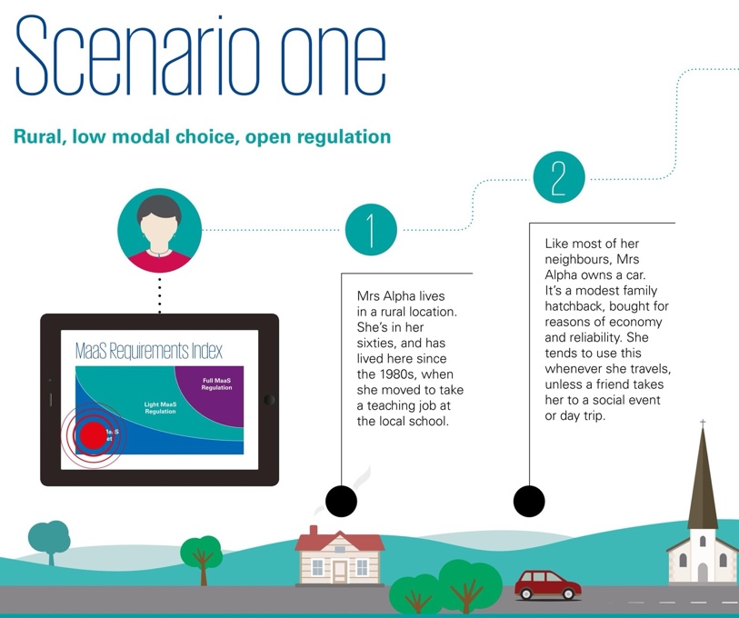

Figure 2 Scenario one: Rural, low modal choice, open regulation (26)
3. METHOD
This section outlines the workshop’s development and execution, shaped by the following main assumptions:
- A Systems Thinking (ST) approach is necessary. ST involves looking at all parts of a complex or ‘wicked’ problem and taking an overarching, rather than ‘piece meal’, view. The complexities of transport in general and MaaS in particular – from the customer/user to technical components e.g. data integration and ticketing, to the stakeholder ecosystem, to policy and its implications – require taking a holistic view.
- A user-centred, problem-solving, Design-Thinking perspective is critical to developing (R)MaaS that can help address users’ needs. As part of the development cycle, customer and/or user engagement and evaluation are central to successful products and services.
The main goals of the workshop were twofold: firstly, to conduct user evaluations of existing MaaS-related technology solutions, and secondly, to test the evaluation tools specifically developed for this task.

3.1 Technology Solutions
The pool of potential technology solutions was identified during two processes; firstly, earlier interviews with international MaaS stakeholders referencing existing providers/solutions; secondly, the lead author’s year-long involvement with the ITF working group on Innovations for Better Rural Mobility (27), providing opportunities to learn about solutions and meet providers. In total, six technology solutions were identified, representing a range of offers. The providers were approached regarding participation (i.e. demonstrate their solutions and be on hand to answer any questions the users might have); all six providers agreed. In return, the providers would receive the user evaluation feedback about their solutions. Although the providers were involved in an array of projects globally, the specific examples tested included two in the UK (rural; urban/regional) and one each in Japan (rural/regional), Sweden (rural), Finland (rural), New Zealand (urban). All technology providers/solutions remain anonymous in this paper.

3.2 Participants/Users
The lead author conducted a co-design stakeholder-mapping exercise to identify relevant RMaaS stakeholders (‘users’ in a broad sense), and workshop participants were recruited based on the results (Figure 3) and the lead author’s network. In total, 25 participants attended (physically or virtually) from the following stakeholder groups: transport providers, transport operators, third-sector transport operator, tourism sector, local business/es, young person/s, elderly person/s, disabled person/s, community organisation/s, local government, higher education, voluntary sector. Many of the attendees represented more than one stakeholder group; a typical characteristic of rural life (28).

3.3 Format and Overview of Workshop
The day-long, hybrid workshop took place at Boat of Garten near Aviemore, Scotland in May 2022. The pandemic delayed the workshop and organisational policies on COVID-19 resulted in some participants needing joining the workshop online (via Zoom) or cancelling their attendance. To ensure that physical attendees did not forget those online, cardboard cut outs of virtual attendees were placed on chairs (Figure 4).
In preparation for the workshop, all participants had either downloaded the app or visited the website of each technology solution. All participants were required to bring a smartphone/tablet to the workshop to access the technology solutions and perform the workshop exercises – ‘a day in the life’, story cubes and persona development, followed by six evaluation sessions (one per technology solution/provider) and one final, holistic evaluation session. All workshop exercises were designed for both in-person and online use.
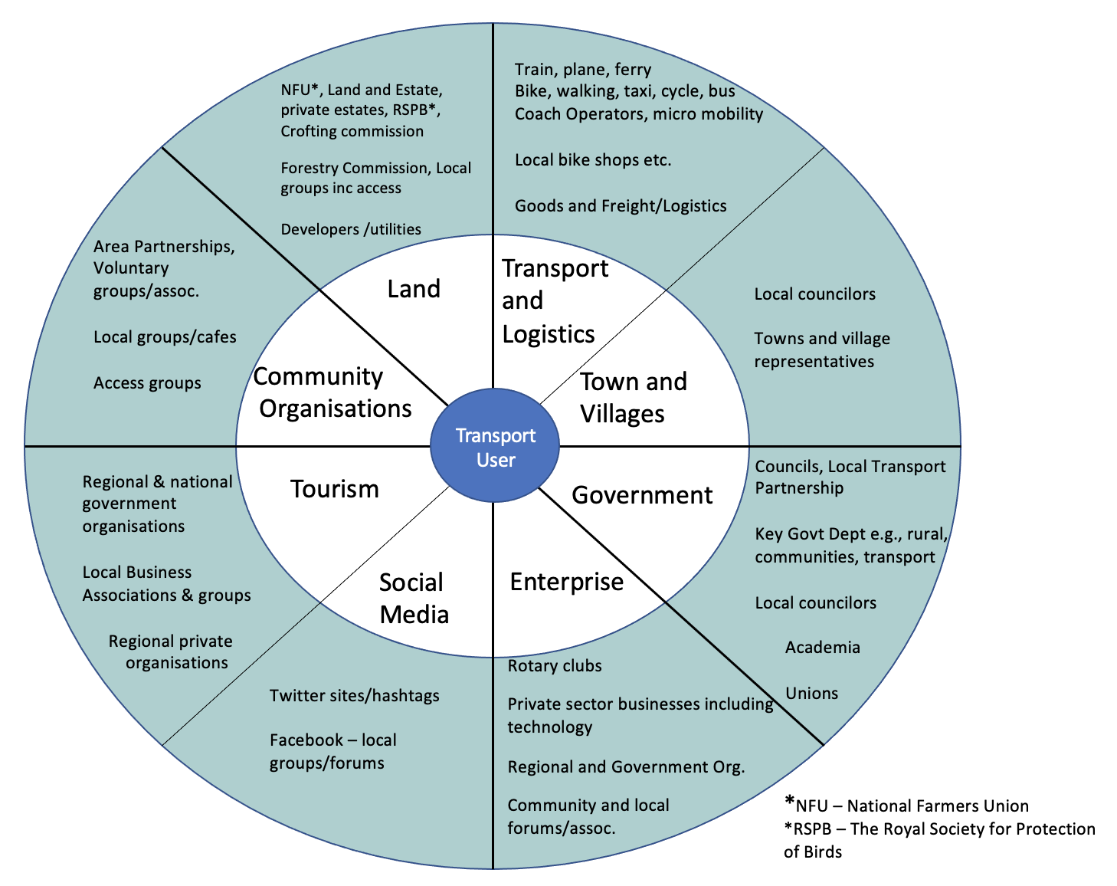

Figure 1 RMaaS/RMobility stakeholder map

Figure 2 Example of cardboard cut-outs representing online attendees
3.4 A Day in the Life, Story Cubes, and Persona Development Exercises
In the opening exercise, ‘a day in the life’, each participant described in words and pictures a typical day in their life, noting any use of travel and drawing on any rural challenges. All participants utilised a common board on the cloud-based, collaborative web platform Padlet.
For the second exercise, nine unique ‘story cubes’ were developed, three each for three themes (users, modes, destinations) (Figure 5a). Cube combinations (e.g. users cube 1 + modes cube 3 + destinations cube 2) were randomised and assigned to each participant in advance. During the workshop, each participant threw their assigned cubes and created a persona based on the resulting combination (Figure 5b). These personas were later used during the evaluation process (described below) and can be utilised in future work. This ‘story cubes’ exercise offers both a dynamic, randomised method to engage participants, and a way for participants to learn and contextualise the challenges and opportunities faced by different types of stakeholders/users.

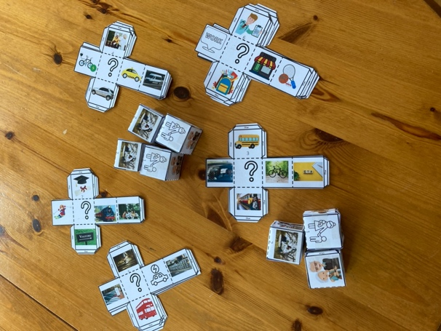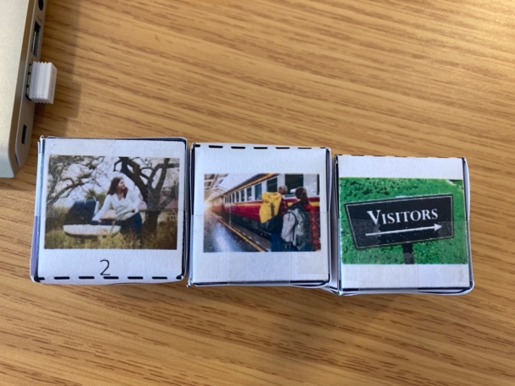

Figure 3 The Story Cubes: (a) design and assembly and (b) three themes (user, mode, destination)

3.5 Evaluation Exercises
When designing the workshop, there were no readily available templates for users to evaluate MaaS technology solutions or similar. Thus, an evaluation toolkit was developed inspired by the Business Model Canvas, which has previously been used in MaaS-related work (29-30). The toolkit comprises two Canvas templates explained to the participants before use. First, ‘Designing Technology for All – Step One’, comprising seven ‘building blocks’ or elements, which participants answered after testing each solution, based on both their own personal mobility experiences but also through the lens of the persona developed earlier. Building block examples include: “Problem: What problems do you think this offering addresses?” and “Impact: How would this offering make a difference to you?” (Figure 6). Second, ‘Designing Technology for All – Final Evaluation / Step Two’, comprising nine elements, which participants filled out once at the end of the day to holistically evaluate their overall experience, insights, and knowledge gathered from testing all the MaaS solutions. This second template explores how the customer relationship should be managed, how revenue could be raised, how participants wished to pay, etc. (Figure 7). The templates’ building blocks provide the structure to the next section.
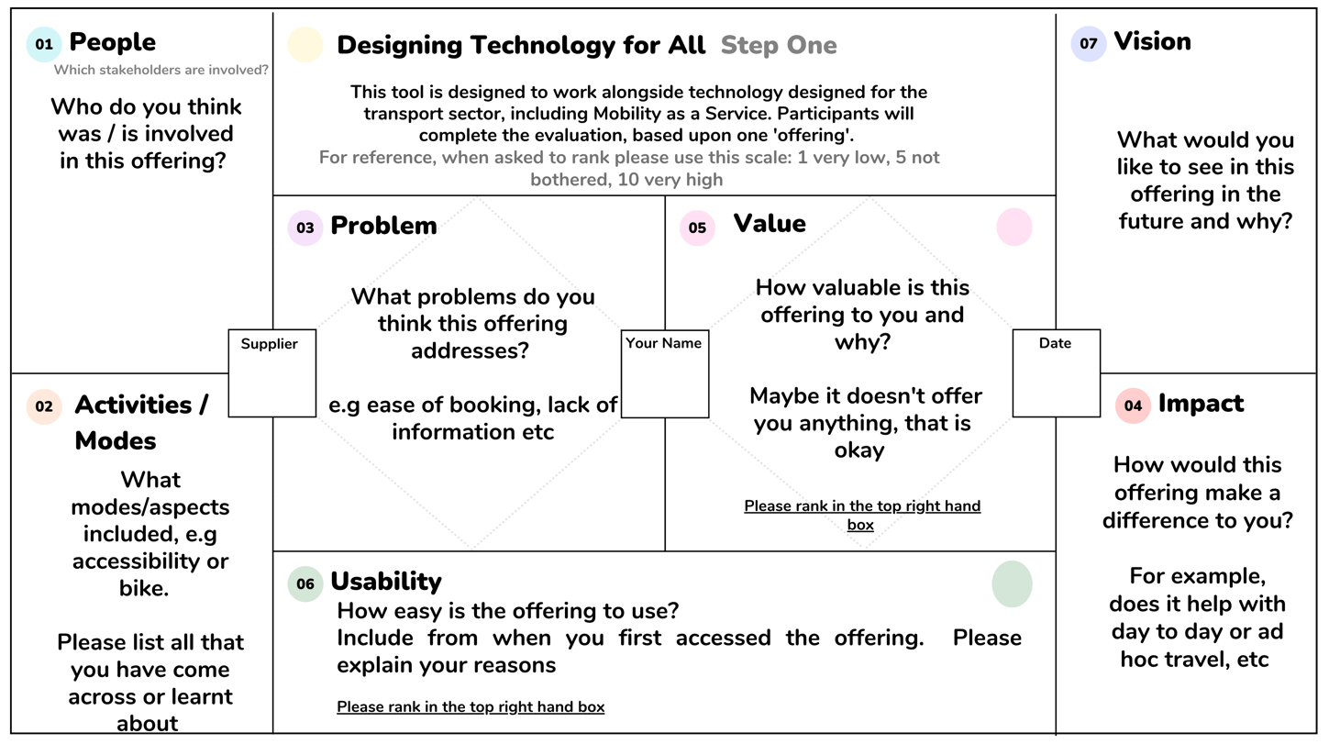

Figure 6 Designing Technology for All – Step One (copyright Jenny Milne)

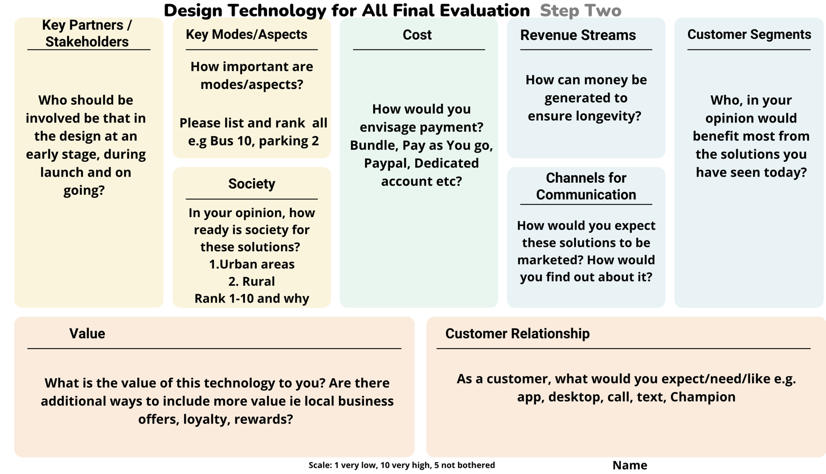

Figure 7 Designing Technology for All – Final Evaluation / Step Two (copyright Jenny Milne)

4. RESULTS AND ANALYSIS
The results and analysis are presented according to the order of the workshop; personas followed by evaluation template elements (Figures 6-7). The section concludes with a proposal to extend the ‘diffusion of innovation’ model.

4.1 Personas
In total, the participants created seventeen unique personas (see Figure 8 for a selection). These were utilised as a tool for reflecting on different users’ transport needs, which assisted in the evaluation process, the results of which are presented below, e.g. RMaaS User Mode Priority Hierarchy (Figure 11b); Potential Impact and Potential Value of RMaaS (Figures 13-14, respectively), and user requirements in the RMaaS Customer Journey Map (Figure 15).
The main reason to create personas was the limited public availability of relevant personas. Also, the available personas were often project specific and limited to that project’s targeted demographic, and/or were developed in a generic manner with traditional characters (e.g. elderly, school child, commuter), and/or were based in urban areas. The personas developed here are cross-sectional, wide-ranging, and provide different perspectives to allow practitioners ‘to walk in another’s shoes’. This method and the resulting personas (available from the lead author) are open for use by other researchers and practitioners when developing or evaluating transport technology solutions.

4.2 People/Stakeholders
Before the evaluation phase, participants discussed which stakeholders they thought were involved with MaaS technology solutions. Later (Step 2), they listed who they thought should be involved. Figure 9 summarises the initial responses. The analysis revealed that the participants’ viewpoints and experiences were influenced by their depth of knowledge of the transport sector. Those working in the mobility sector detailed more service providers and technical partners, whilst end users of services focused more on trip purpose/destination, e.g. doctor/hospital, school/college. All participants acknowledged different end user types from occasional commuters to visitors. Of note: upon answering the question in Step 2, after a day exposed to the MaaS concept and technology solutions, the number and variety of stakeholders increased, particularly for the categories Community Organisations, Tourism, and Enterprise (Figure 10).
The evidence suggests it requires a collaboration of participants to identify key MaaS stakeholders, but even then, this may not provide an exhaustive or detailed list. For example, previous explorations of MaaS stakeholders have identified seven actors in the MaaS business ecosystem (transport operators, data providers, technology/platform providers, ICT infrastructure, insurance companies, regulatory organisations, and universities/research institutions) (31) but did not consider local stakeholders; and indicated eight frequently involved actors in rural MaaS pilots (regional PTAs, municipalities, civic organisations, local businesses, technology providers, commercial mobility service providers, research institutes, and national authorities) (32) without identifying the travelling public. However, this emphasises rather than negates the importance of bringing in different perspectives, as “it serves a common goal [to create realistic mobility solutions] to use these human-centred perspectives to achieve different organisations’ interests in a socially sustainable way” (33:15). As demonstrated here, the involvement of local citizens, representatives, and businesses enriched the identified relevant stakeholder map via insights into e.g., trip purposes, associated organisations, and the ‘softer’ needs of users (e.g. inclusion and social value, vehicle type and trip timing) which help shape the ‘who’ or ‘people’ required to actualise RMaaS.
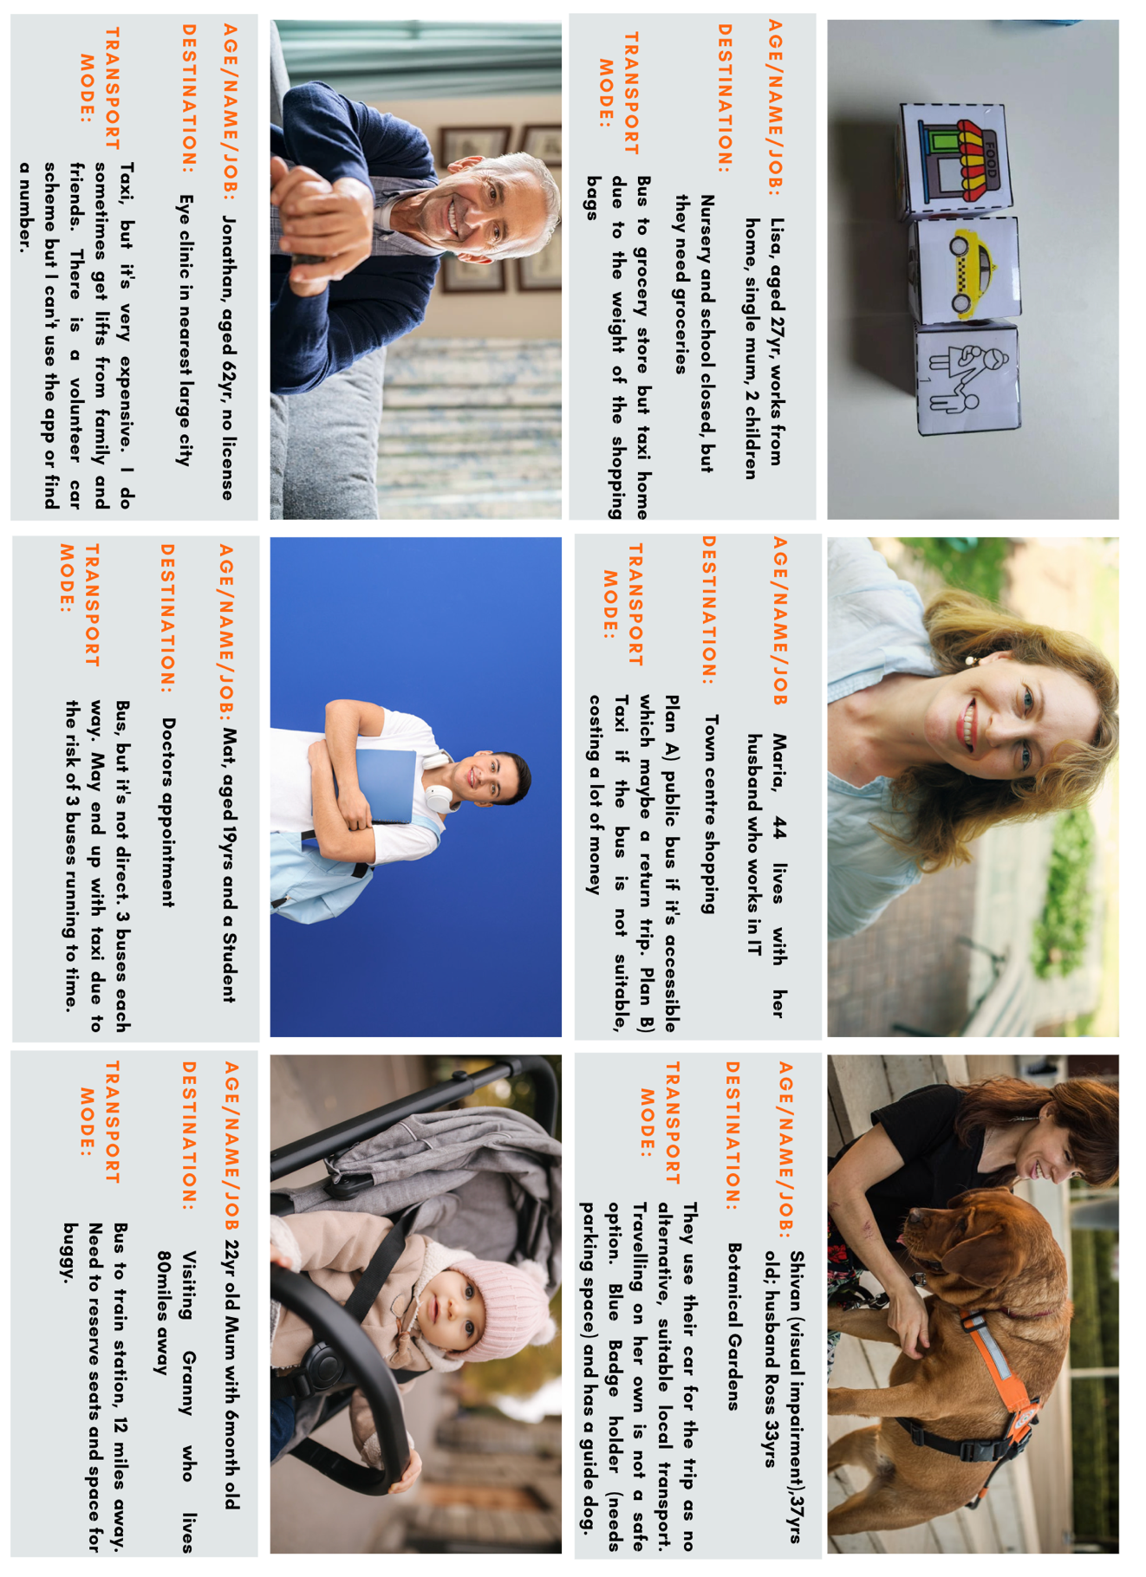

Figure 8 Co-designed personas (selected)
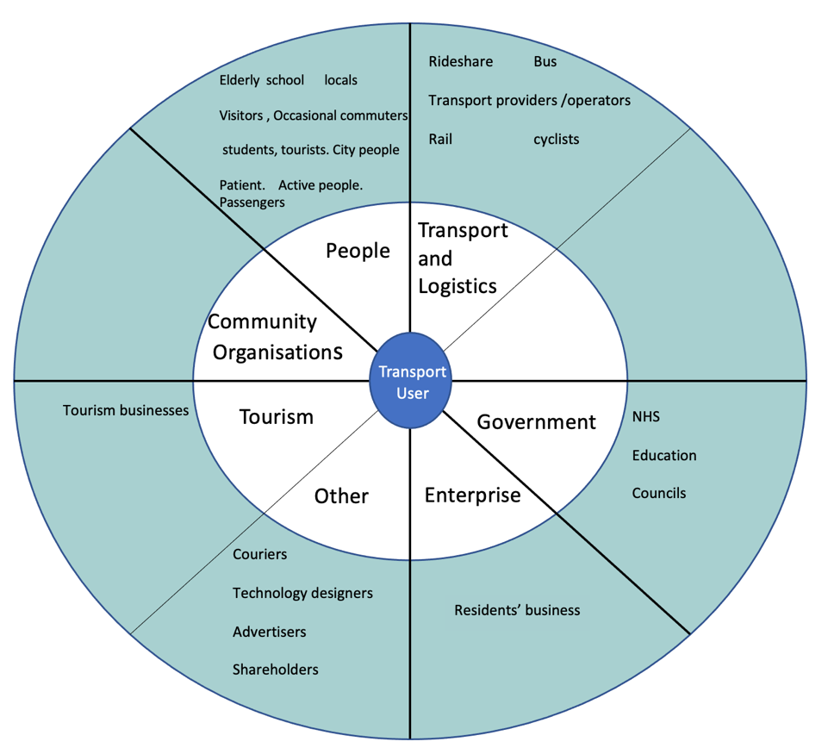

Figure 9 Initial stakeholder analysis (pre-Step 1 evaluation)

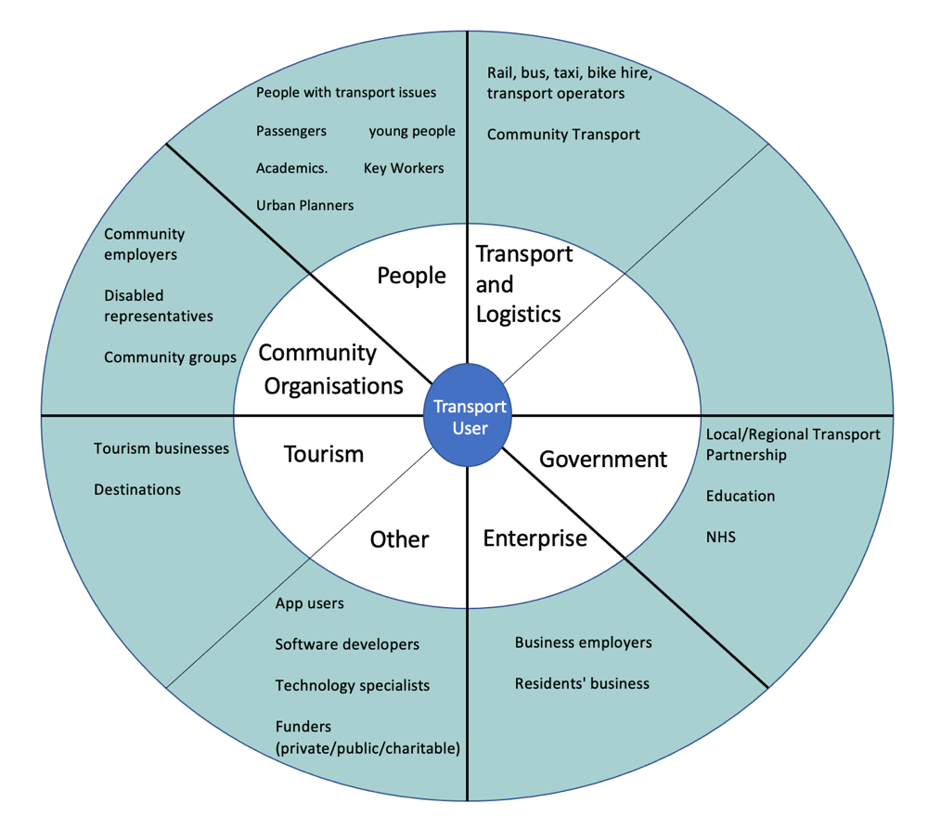

Figure 10 Final stakeholder analysis at the end of the workshop (Step 2 evaluation)

4.3 Modes/Activities
In Step 1, each participant noted which transport modes they found in each solution. To visualise the modes currently included in (these six) MaaS solutions, an analysis subsequently ranked the modes in order of the number of times each had been found. The scheduled bus achieved the highest rank, followed by train, taxi (individual and shared), and private bike; these form the ‘Core’ of what is currently offered (Figure 11a). Walking, Demand Responsive Transport (DRT), car rental, and air travel were either included fewer times and/or less easily found (‘Level 1’), whilst high-speed rail, carsharing (US carpooling), car clubs (US carsharing), community transport (volunteer/community-led solutions for meeting unmet local transport needs), private car, school buses, bike share, and ferry were all in one or more MaaS solutions but were included/found to a much lesser degree (‘Level 2’). It is noteworthy that no participant found modes relating to ‘peer-to-peer’ options or coaches (hired or long-distance buses) in any of the solutions.
In Step 2 (final evaluation) regarding modes, participants listed and ranked modes according to their importance. The subsequent analysis revealed distinct clusters, as illustrated in Figure 11b. Comparing Figures 11a-b highlights both matches and mismatches between what (these six) MaaS solutions offer (Figure 11a) and what RMaaS users prioritise (Figure 11b). Bus, train, and bike all featured strongly in both the current offering and users’ priorities. However, although possibly in part due to the day-long exposure to different modes, terminologies and solutions, participants prioritised a variety of modes that are not currently offered, including scooter rental, motorbikes, taxi share (as a dedicated mode, to lower costs), horse, parking, and the private car. The ranked importance of some modes also led to a placement shift, e.g. community transport shifted from Level 2 to Level 1, private car shifted from Level 1 to Core, and taxi shifted from Core (individual or shared) to Level 2 (shared only). Such discrepancies between service offerings and users’ priorities must be addressed if RMaaS is to help address rural dweller’s needs and requirements.
In “rural communities, transport can be defined by choice, or rather the lack of it” (34:5). The “availability of transport is key” (35:5) and the value of any solution is inextricably linked to available transport infrastructure. Given the lack of infrastructure in rural areas, particularly of bus services (36), different models (e.g. business, operator, financing) and modes are being suggested. For example, shared taxi rides as the “skeleton of a MaaS service network” supported by public transport (7) or improved “short-range travel for social and community purposes” (37). In the end, the “needs of the residents and potential passengers should be the deciding factor when identifying the area that the…services will cover” (38:9). But currently, this is not happening (enough), e.g. existing offerings forward the ‘core’ role of the taxi (individual or shared), but user priorities do not support this (Figures 11a-b). Reminding oneself of at least one vision of MaaS: “The aim is for the user to have various easy-to-use and affordable mobility options. Services must be available to address the user’s mobility needs and be easy to combine … Mobility services must provide reliable and timely information and guidance through different devices and means (such as smart phones and social media).” (39:48).
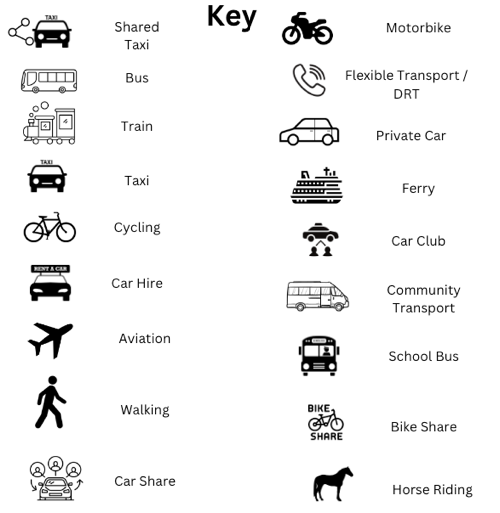
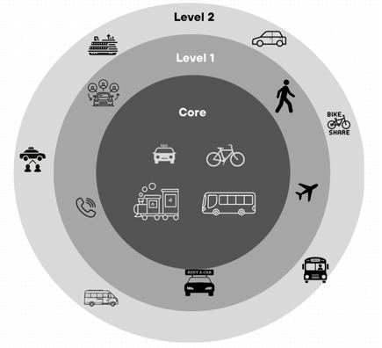 | 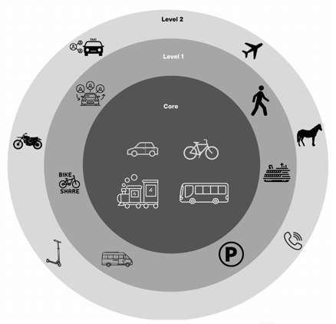
Figure 11 Modes
(a) modes currently found/featured in MaaS offerings (left);
(b) RMaaS User Mode Priority Hierarchy (right)

4.4 Problem
The ‘Problem’ element proved challenging in that it required participants to identify which problems they think the technology solution is trying to solve; a question often avoided in the transport sector’s MaaS debate. The analysis of the comments (exemplified in Figure 12) revealed views of MaaS as a tool to address four main themes: 1) demographic changes, 2) poor transport infrastructure, 3) multimodal facilitation whilst also 4) personalising travel. The latter three themes directly fall under the responsibility of the public authorities in charge of transport and mobility, whilst the first theme, demographic changes, is a broader societal trend to be addressed via policy, e.g. migration away from rural areas due to lack of available and affordable housing. Thus, according to the participants, MaaS can or should be considered an institutional tool for implementing policy.

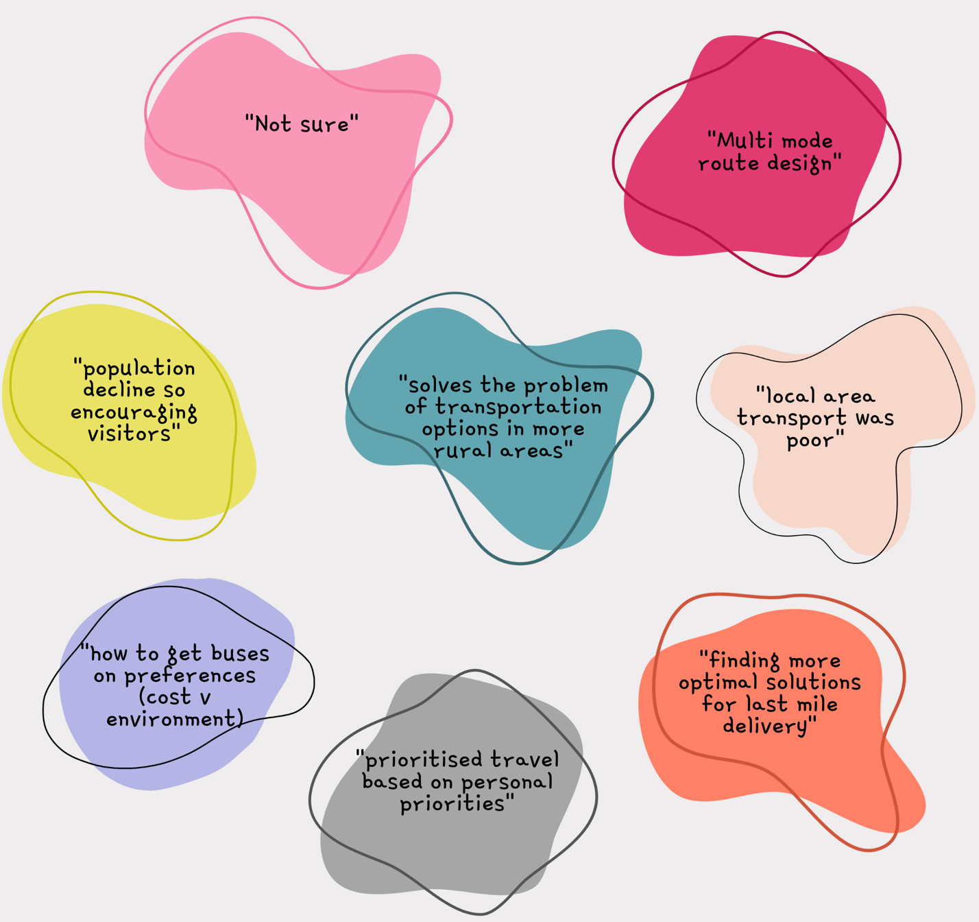

Figure 12 Representative responses across all six solutions to the ‘Problem’ element in Step 1 – What problem is the offering trying to solve?

4.5 Impact

When asked how each offer would make a difference in daily life, participants needed to consider the potential impact of the solution on themselves and on their persona created earlier in the workshop. In the analysis of the responses, five impact categories emerged: modes, trip purpose, travel behaviour, finances, and society (Figure 13). These five impact categories offer a potential framework to evaluate the impact of RMaaS, although the challenge remains in capturing and measuring many of these impacts.

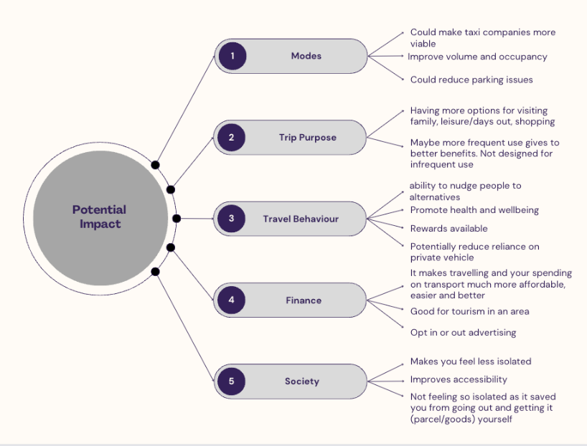

Figure 13 Potential impacts framework – categories and examples

The participants felt that RMaaS solutions could improve service volume and occupancy rates, particularly for taxis, which would reduce parking pressures in villages and at tourist destinations. However, when discussing trip purpose, it was felt that RMaaS is not designed for infrequent travellers, but equally participants felt it would improve travel options for leisure purposes, shopping and/or visiting family. It was thought that this would provide a societal benefit by reducing isolation and improving accessibility. Participants also felt RMaaS would suit tourist areas, where visitors could monitor expenditures but also receive tailored offers/trips, which could include the delivery of local products and services (for residents as well).
Changes in travel behaviour are considered as a potential, positive outcome of MaaS (40) and in a rural context, participants did acknowledge MaaS’ potential to reduce reliance on a second or third car, but emphasised that the private car is essential. The option to receive rewards and/or marketing was explored due to that functionality existing in some of the solutions. In general, a reward option for undertaking or supporting a particular trip was welcomed. There were concerns about streaming advertisements related to practical or content-related matters such as data consumption, driving distractions, and content appropriateness. Overall, RMaaS was considered a positive tool to encourage modal shift and promote health and wellbeing.

Participants were mindful that rural transport costs are higher due to the distances travelled. They viewed RMaaS as providing value by centralising costs, providing a better overview and potentially making travelling more affordable and easier to understand (budget, patterns, etc.). The opportunity to earn points or cash through rewards garnered a mixed response, with the suggestion of an ‘opt in/out’ to advertising and rewards.

4.6 Value
Participants were asked to assess the potential value of each MaaS solution, whilst also considering their persona. (They were also asked to score each solution.) Three categories emerged from the responses: modes, user experience and travel behaviour (Figure 14).

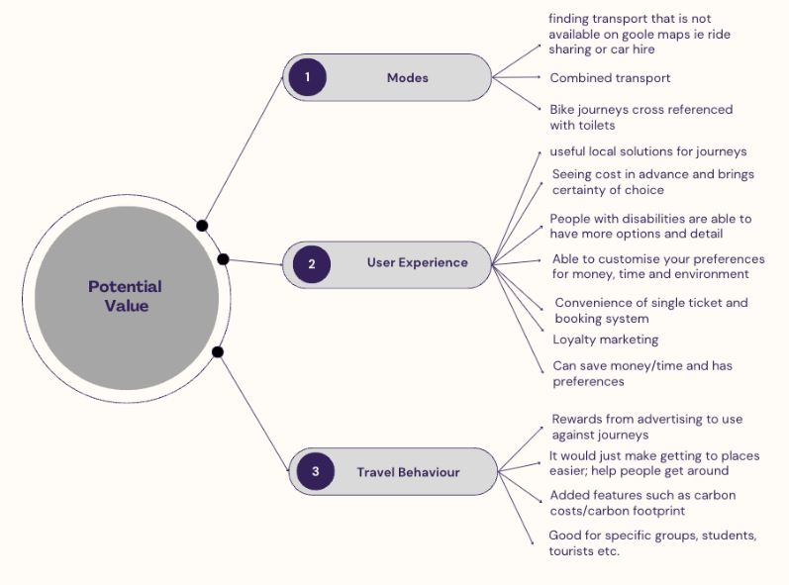

Figure 14 Potential value framework – categories and examples

Participants were favourable to combining modes and improving the trip experience (cf. MaaS Lite (41)). Trip planning featured with the observations that GoogleMaps often provides neither accurate rural transport information nor ride- or carsharing (US carpooling). Finding details such as toilet locations or advance price information would bring certainty and trust, which were important to the participants.
The user experience for disabled travellers was highlighted repeatedly, from meeting Web Content Accessibility criteria (WCAG 2.1AA) to making a ‘welcoming’ interface, to providing customers with practical details such as vehicle design, toilet locations, or relevant contact numbers. But the ability to customise preferences (e.g. travel time, cost, carbon footprint) was viewed as generally valuable. It was argued that such functionalities would save time with future trip planning and thus increase the probability of using the RMaaS transportation offerings.
Loyalty marketing, whereby incentives are provided such as rewards towards trips, divided participants, but for some, this is where the potential value can be found. The ability for some to offset high rural transport costs would not only improve their social mobility, but also their employment and education opportunities. This functionality has the potential to help with rural transport poverty.
Keeping in mind that “it is important that MaaS adds enough value for travellers” (39:3), participants ranked the potential value of each solution (1-10). Two solutions scored 55-56% and the remainder 71-75%. All the solutions were considered to have value, but with different strengths and weaknesses.

4.7 Useability
Participants were asked how easy each solution was to use, from when they first accessed it (including reasons). Usability was also scored 1-10, and the average scores for the solutions ranged from 55% to 79%. The reasons provided by the participants were subsequently collated across all six solutions and organised into a ‘customer journey’ map (Figure 15) that includes touch- and pain points from the beginning of the process (research and planning) through to the end of the trip (post travel/use).
The touch- and pain points provide useful insights into users’ considerations. Pain points ranged from needing to create an account before using the app, needing a smartphone, and Wi-Fi/data reliance, to needing to understand more fully what the benefits are over GoogleMaps and the constant user interaction required, even after the journey is completed. Some of the ‘wish list’ functionalities, which participants were keen to embrace, were under development, e.g. 24/7 customer support, push notifications on disruptions, links to local businesses and to digital services such as online calendars, and trip segments coloured by mode on the map. (Authors’ note: colour-blindness was not brought up but would need to be taken into consideration with the introduction of such a functionality.)
Frequently, potential users download an app or access a website and encounter a difficulty, which can result in discontinued use. Usability and the ‘MaaS user interface’ (40) can be considered the beginning of the ‘shopping experience’. Thus, to improve the user experience (and minimise discontinued use), these touch- and pain points should be considered by any MaaS solution (cf. (42)). It must however be acknowledged that MaaS apps/websites do not have control over transport mode-related pain points (43).

4.8 Customer Relationship and Communication
As the participants had access to the six solutions before the workshop, they were able to utilise any customer support prior to the event. When answering the ‘customer relationship’ element, all participants were keen to see improvements with at minimum nine-to-five daily phone support. The option to text support 24/7 or utilise an AI assistant for the most common issues was also desirable. Other options included instant messaging or web chat. The feedback implied that this is an area of improvement for all six solutions.
Participants were also asked how they would expect to ‘find’ a MaaS solution (app or website) – ‘channels for communication’ element – with the answers forming the basis of a marketing strategy. Suggestions included social media, local news, press releases, local businesses, tourist products and documents, word of mouth, events, local radio, newspapers, and flyers. Two creative suggestions were inclusion in Lonely Planet for vacation and using social media influencers.
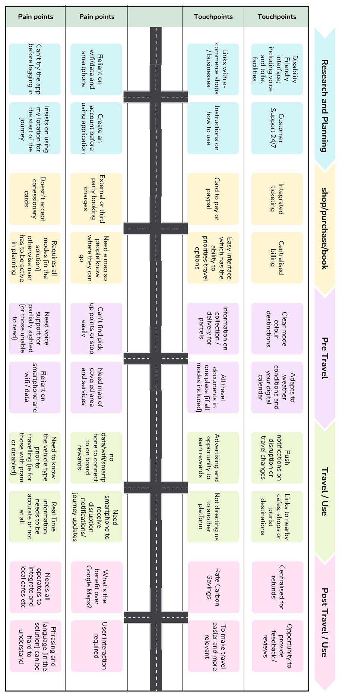

Figure 15 RMaaS Customer Journey Map
4.9 Target Customer(s)
When asked ‘Who would benefit the most?’, the participants’ responses (based upon their own knowledge and their personas) reflected those proposed for key stakeholders in Figures 9 and 10 and covered many customer segments, although fundamentally the participants deemed the ‘rural public’ as the main target customer. The list included communities, businesses, local employees, co-workers, commuters, patients, students, couples, disabled people, those without cars, and visitors.
This is a wide and diverse range of the population, but it reflects the demography and dynamics of rural areas. Although it may also reflect urban areas generally, the characteristics of rural and urban life differ. For example, those without cars in rural areas will not have the same availability of other options, which restricts choice; and urban bus services are more comprehensive and frequent. Thus, the target customer for RMaaS needs to be inclusive whilst also being diverse, which is challenging as no one size fits all.

4.10 Payment and Financing
When asked about payment methods, participants generally agreed that there needs to be flexibility (cf. (39)), but concessionary or specialised/discount cards need to be accepted. Ultimately the participants wished for ‘integrated prices paid by your choice’ by Pay-As-You-Go (PAYG) methods like PayPal, debit card or GooglePay. However, it was highlighted that operator payment methods have changed since the COVID-19 pandemic with cash not as readily accepted, so a counter argument was presented: in certain locations there may be a need for a ‘specific card for transport which would bundle services together’, predominantly where data services are poor and card machines do not operate. Subscription plans were not favoured (cf. (44)) as travel needs vary by season and weather. (Authors’ note: this likely assumes an unmodifiable subscription.)
Many of the current MaaS pilots, especially non-urban, rely on public funding. As public expenditure lessens, there are desires to increase private sector funding for MaaS, such as in Japan. When asked about generating funds to ensure longevity, participants’ answers were wide-ranging and included several different operational approaches.

“Commission from transport providers”

“Council funding as initially it has to be local”

“Advertising from businesses, local hotels, etc.”

“Community benefit as businesses that benefit pay a percentage of the cost to supply people to the area”

“Charitable funding, advertising”

“Overall membership”

“Marketing of the solution increases revenue streams for transport operators”

4.11 Adopting an Innovation
The findings from the two-step evaluation inspired the proposal of a further extension to the ‘diffusion of innovation’ process by which innovations spread through society via of adoption (or rejection) (45). The original five-stage process includes knowledge, persuasion, decision, implementation, and confirmation. Subsequent research proposed two sub-levels to implementation, namely acclimatization and normalization (46 in 1) (Figure 16). Based on the workshop results, a six-stage ‘End-User Adoption of Innovation Model’ is proposed for MaaS (rural and urban) (Figure 17).

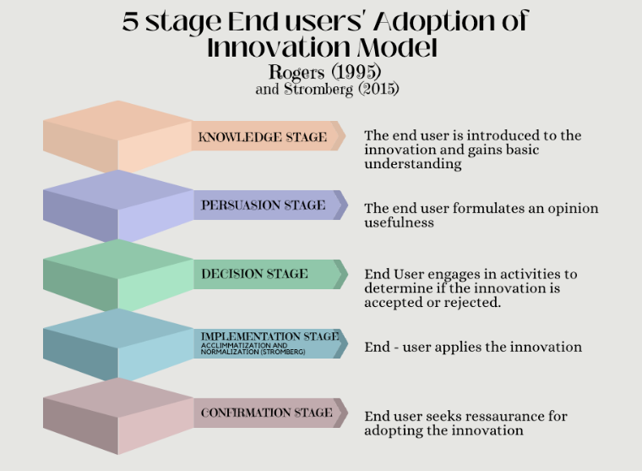

Figure 16 Five-stage ‘End Users' Adoption of Innovation’ model;
authors’ illustration based on (45, 46 in 1).

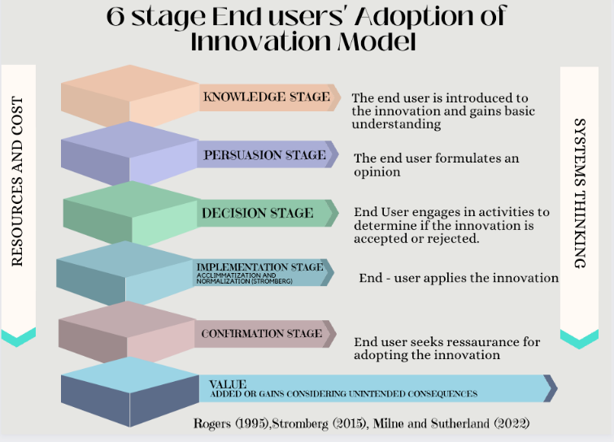

Figure 17 Six-stage ‘End Users' Adoption of Innovation’ model (copyright Milne and Sutherland)
During the workshop, the participants became familiar with MaaS solutions (knowledge) and the process of evaluation (persuasion) with the final evaluation (decision) ending the practical journey. Stages four and five, implementation and confirmation where the user applies the innovation in daily life, were theoretically experienced via the participants’ completion of ‘Designing Technology for All – Final Evaluation / Step Two’ (Figure 7) as the participants considered the value of the innovation and socially accepted the MaaS solution (47). Alternatively, this acceptance provides a ‘social licence’ (9); another way of demonstrating value.
Additionally, key themes emerged in the discussions. Participants expressed concerns over resource availability and cost. They strongly advocated a holistic view, where innovations such as MaaS should be viewed as a system rather than individual or siloed stages of development and implementation. This introduced the approach of Systems Thinking to help address what is often viewed as a complex or ‘wicked’ problem. And, finally, aspects of value, including unintended consequences, as participants realised that innovations bring positive, negative, and unforeseen impacts and that these should be considered and monitored; particularly the unforeseen, as users should be kept informed of such impacts. These key themes are included in the proposed model extension (Figure 17).

5. CONCLUDING REMARKS
This workshop and its outputs contribute to the four key objectives of the larger RMaaS research project. Firstly, to identify use cases which was achieved through the co-creation of personas (§4.1, Figure 8) and the stakeholder map contributions (§4.2, Figure 10). Much pre-existing persona work not publicly available (although some has been viewed privately by the lead author), thus these personas offer a much-required tool. Secondly, the objective on user requirements was fulfilled via the development of the RMaaS Customer Journey Map (§4.7, Figure 15), discussions on the customer relationship (§4.8), etc. Co-creating such a map for MaaS in general presents an opportunity for future work. The customer journey specifically and workshop results generally address the third objective on barriers and opportunities, as does the creation and testing of the evaluation templates (§3.5, Figures 7 and 8) which enabled data collection. Fourth and finally, evaluating MaaS solutions in the context of transport poverty and a lack of transport infrastructure was achieved via the workshop evaluation in general, but by creating the RMaaS User Mode Priorities Hierarchy in particular (§4.3, Figure 11). The contrast between existing and desired mode offerings (Figures 11a and 11b, respectively) demonstrates clear mismatches between current solutions and users’ needs. The evidence demonstrates that there is no value if the available infrastructure is lacking. Consequently, infrastructure (and mobility) gaps and (R)MaaS’ value are inextricably linked. This mismatch needs addressed to increase RMaaS’ attractiveness and reduce transport inequalities and poverty.
The existing scientific literature typically fails to focus on the user, Design Thinking and/or co-design in the field of MaaS. It also rarely provides practical insights and testing of MaaS technology solutions with a wide variety of users and stakeholders. In general, service providers and municipalities are not undertaking this ‘natural step’ which fundamentally underpins the potential for value, economic viability, and success. It is recommended that municipalities/regions consider user trials before (or during) rather than after procuring a solution. Furthermore, as the value chain is very diverse, the focus should not solely be on direct financial value but social and environmental value.
This unique workshop presents a model for others to use. The public, private, and community sectors, users and providers, were able to address the complex problem of RMaaS together through the testing and evaluation of real-world technology solutions and software. Critically, the participants provided user-centric feedback and insights whilst adopting a Systems Thinking approach, which permitted the various ‘parts’ (modes, added value, payment, etc.) to be reviewed in the context of the ‘system’ (MaaS and mobility). Ultimately this interactive workshop approach facilitated the participants’ viewing of the individual parts of MaaS from an interwoven, holistic perspective.
This research is innovative in terms of the depth of engagement and the diversity of those participating and its active involvement of the public and private sectors in evaluating MaaS technologies. The hybrid methodology and interactive tools and frameworks used, including story cubes and evaluation templates, provided via online platform and in person, provided for an inclusive and sustainable workshop. This research focus on rural areas and mobility contributes to the further development of RMaaS, and, finally, its applied nature provides practical tools and templates available for not only RMaaS practitioners, but all MaaS practitioners.

6. AUTHOR CONTRIBUTIONS
The authors confirm contribution to the paper as follows: study conception and design: J. Milne, C. Cottrill^; data collection: J. Milne; analysis and interpretation of results: J. Milne, M. Beecroft, J. Sochor; draft manuscript preparation: J. Milne, J. Sochor, M. Beecroft. All authors reviewed the results and approved the final version of the manuscript.

7. REFERENCES
1. Smith G., J. Sochor, I.C.M. Karlsson. Adopting Mobility as a Service: An empirical analysis of end-users’ experiences. Travel Behaviour and Society, 2022. 28:237–248.

2. Sochor, J., I.C.M. Karlsson, H. Strömberg, H. Trying Out Mobility as a Service: Experiences from a Field Trial and Implications for Understanding Demand. Transportation Research Record: Journal of the Transportation Research Board, No. 2542, 2016. 4:57–64.

3. Eckhardt J., L. Nykänen, et al. MaaS in rural areas - case Finland. Research in Transportation Business and Management, 2018. 27:75–83.

4. Eckhardt J., A. Lauhkonen, A. Aapaoja. Impact Assessment of Rural PPP MaaS pilots. European Transport Research Review, 2020. Vol. 12.

5. Fioreze, T., M. de Gruijter, K. Geurs. On the likelihood of using Mobility-as-a-Service: A case study on innovative mobility services among residents in the Netherlands. Case Studies on Transport Policy, 2019. 7:790–801.

6. Polydoropoulou A., I. Pagoni, A. Tsirimpa. Ready for Mobility as a Service? Insights from stakeholders and end-users. Travel Behaviour and Society, 2020. 21:295–306.

7. Liu, X., J. Yu, et al. Exploring the Feasibility of Mobility as a Service in Small Urban and Rural Communities: Lessons from a Case Study. Journal of Urban Planning and Development, 2020. Vol. 146.

8. Sochor, J. Piecing Together the Puzzle Mobility as a Service from the User and Service Design Perspectives. International Transport Forum Discussion Papers, No. 2021/08, OECD Publishing, Paris, 2021.

9. Broderick A. The Future of Rural Transportation and Mobility for Older Adults: Current Trends and Future Directions in Technology-enabled Solutions. Beyond Here & There: Transforming Mobility in Rural America through New Technology summit, UC Berkeley, 2018. Accessed June 1, 2023. https://www.giaging.org/documents/180424_CITRIS_rural_mobility_paper_F.pdf

10. Design Council. The Double Diamond: A universally accepted depiction of the design process. Design Council Website, 2019. Accessed June 1, 2023. https://www.designcouncil.org.uk/our-resources/archive/articles/double-diamond-universally-accepted-depiction-design-process/

11. Brown, C., M. Hardman, et al. Mobility as a Service: Defining a Transport Utopia. Future Transportation 2022. 2:300–309.

12. Chinnock, C., K. Mackay, et al. Putting the user at the heart of decision making: A reflection on applying the double diamond to enhance understanding of the customer for Mobility as a Service. Presented at Australian Transport Research Forum, Adelaide, Australia, 2022.

13. Sarasini, S., I.C.M. Karlsson, et al. From vision to reality: How service design processes shape Mobility as a Service offerings. Presented at 3rd ICoMaaS, Tampere, Finland, 2022.

14. ITF. The Innovative Mobility Landscape: The Case of Mobility as a Service. International Transport Forum Policy Papers, No. 92, OECD Publishing, Paris, 2021.

15. Blomkamp E. The Promise of Co-Design for Public Policy. Australian Journal of Public Administration, 2018. 77:729–743.

16. Lorenzini, A., S. Gini. Business models for inclusive mobility – guidance for successful implementation. INCLUSION EU project, 2020. Accessed June 1, 2023. http://www.h2020-inclusion.eu/fileadmin/user_upload/Documents/Deliverables/inclusion_project_D6.2_FINAL_web.pdf

17. Zardini G., N. Lanzetti, et al. Co-Design to Enable User-Friendly Tools to Assess the Impact of Future Mobility Solutions. IEEE Transactions on Network Science and Engineering, 2023. 10:827–844.

18. Hesselgren M., M. Sjöman, A. Pernestål. Understanding user practices in mobility service systems: Results from studying large scale corporate MaaS in practice. Travel Behaviour and Society, 2018. 21:318–327.

19. Ho C., D. Hensher, et al. MaaS bundle design and implementation: Lessons from Sydney MaaS trial. Transportation Research Part A: Policy and Practice, 2021. 149:339–376.

20. Cooper, A. The Inmates Are Running the Asylum. Macmillan Publishing Co., Indianapolis, 1999.

21. Pirinen P. Developing personas for studying transport poverty: Case the City of Vantaa. Master’s Thesis. Aalto University, 2022.

22. Bradley C., L. Oliveira, et al. A new perspective on personas and customer journey maps: proposing systemic UX. International Journal of Human-Computer Studies, 2021. 148:102583.

23. Polst S., P. Stupfer. A Comprehensive Persona Template to Understand Citizens' Mobility Needs. In HCI in Mobility, Transport, and Automotive Systems. LNICS 11596 (H. Krömker, ed.), Springer, Cham, 2019, pp. 295–306.

24. Vallet F., J. Puchinger, et al. Tangible futures: Combining scenario thinking and personas - A pilot study on urban mobility. Futures, 2020. 117:102513.

25. Chinnock C. Who are you planning for? Ensuring transport equality through a better understanding of our customers. IMOVE Conference, November 14, 2022. Accessed June 1, 2023. https://imoveaustralia.com/wp-content/uploads/2022/11/iMOVE-Presentation-Chris-Chinnock.pdf

26. Fousler B. Reimagine Places: Mobility as a Service. KPMG, 2017. Accessed June 1, 2023. https://assets.kpmg.com/content/dam/kpmg/uk/pdf/2017/08/reimagine_places_maas.pdf

27. ITF. Innovations for Better Rural Mobility. Accessed December 22, 2021. https://www.itf-oecd.org/innovations-better-rural-mobility
28. Steiner, A., J. Atterton. The contribution of rural businesses to community resilience. Local Economy, 2014. 29:228–244.

29. Mengal, D. Customer Directed Mobility Management, New York State Energy Research and Development Authority Proposal including Attachment A, B and Executive Summary, 2010.

30. Eckhardt, J., A. Aapaoja. Figure 21: Business model canvas for a MaaS operator. In: König, D., Eckhardt, J., et al. Deliverable 3: Business and operator models for MaaS. MAASiFiE project funded by CEDR, 2016. Accessed July 25, 2023. https://projectsites.vtt.fi/sites/maasifie/www.vtt.fi/sites/maasifie/
PublishingImages/results/cedr_mobility_MAASiFiE_deliverable_3_revised_final.pdf

31. Kamargianni, M., M. Matyas. The Business Ecosystem of Mobility as a Service. Presented at 96th Annual Meeting of the Transportation Research Board, Washington D.C., 2017.

32. Hult, Å., L. Perjo, G. Smith. Shared Mobility in Rural Contexts: Organizational Insights from Five Mobility-as-a-Service Pilots in Sweden. Sustainability, 2021. 13:10134.

33. Pink, S., R.C. Smith, et al. Mobility as a Service Through Design: A Human Approach. In Advancing a Design Approach to Enriching Public Mobility (S. Coxon, R. Napper, eds.), Springer, Cham, 2021, pp.1–17.

34. FutureGov. Ready for Innovation: The Opportunity for the Innovation in Rural Transport. Transport Systems Catapult, 2017. Accessed July 26, 2023.
https://cp.catapult.org.uk/wp-content/uploads/2021/07/Ready_for_Innovation.pdf

35. Bernhart, W., H. Kaise, et al. Reconnecting the rural – Autonomous driving as a solution for non-urban mobility. Roland Berger Focus, 2018. Accessed June 1, 2023. https://www.rolandberger.com/publications/publication_pdf/roland_berger_reconnecting_the_rural_1.pdf

36. Campaign for Better Transport. The future of rural bus services in the UK. Campaign for Better Transport, 2018. Accessed June 1, 2023. https://bettertransport.org.uk/wp-content/uploads/legacy-files/research-files/The-Future-of-Rural-Bus-Services.pdf

37. Shergold, I., G. Parkhurst, C. Musselwhite. Rural car dependence: an emerging barrier to community activity for older people. Transportation Planning and Technology, 2011. 35:69–85.

38. ARTS. Rural Transport Handbook. ARTS Actions on the Integration of Rural Transport Services, 2004. Accessed June 1, 2023. https://trimis.ec.europa.eu/sites/default/files/project/documents/
20070228_145610_38413_ARTS_Rural_Handbook.pdf

39. Nylund, N.-O., K. Belloni (eds.). Smart sustainable mobility – A user-friendly transport system is a combination of intelligence, low carbon energy, and adaptable services. VTT, Finland, 2014. Accessed July 26, 2023. https://www.vttresearch.com/sites/default/files/pdf/visions/2014/V5.pdf

40. Durand A., L. Harms, et al. Mobility-as-a-Service and changes in travel preferences and travel behaviour: a literature review. KiM Netherlands Institute for Transport Policy Analysis, 2018. Accessed June 1, 2023. https://trimis.ec.europa.eu/sites/default/files/project/documents/mobility-as-a-serviceandchangesintravelpreferencesandtravelbehaviour.pdf

41. Pickford, A., E. Chung. The shape of MaaS: The potential for MaaS Lite. IATSS Research, 2019. 43:219–225.
42. Wockatz, P., P. Schartau. Traveller Needs and UK Capability Study: Supporting the realisation of Intelligent Mobility in the UK. Transport Systems Catapult, 2015. Accessed July 26, 2023. https://cp.catapult.org.uk/wp-content/uploads/2021/07/Travellers_Needs_and_UK_Capability_Study.pdf

43. Huang Y., D. Hands. Design Thinking for New Business Contexts: A Critical Analysis through Theory and Practice. Palgrave Macmillan, Cham, 2022.

44. Sjöman, M., T. Ringenson, A. Kramers. Exploring everyday mobility in a living lab based on economic interventions. ETRR, 2020. 12:5.

45. Rogers, E.M. Diffusion of Innovations. Simon and Schuster, New York, 1995.

46. Strömberg, H. Creating space for action – Supporting behaviour change by making sustainable transport opportunities available in the world and in the mind (Doctoral thesis). Chalmers, Gothenburg. Accessed July 26, 2023. https://research.chalmers.se/publication/222635

47. Tran, Y., N. Hashimoto. Mobility-As-A-Service Trials in Japan: Initial Result. IEEE ICCE, Las Vegas, USA, 2022.

